Samuel Gest

Professor Carver

SDEV140

July 26, 2022

Welcome to Sam’s Discount Shoes User Manual

If you are reading this, you are probably a sneakerhead who likes finding great deals on all the most fashionable shoes. As you can see, we offer a small selection of shoes at a very discounted price.

Main window:

This is the main window. As you can see there are 8 different styles of shoe you can choose from. There are spin boxes for each style of shoe so that you can choose the amount of shoe you want.

Once you have selected which shoes you want and the amount, you can click the “Total” button. This button will calculate the total price of your order.

After you have done this there are a few different options you can do:

1. You can “Clear Order”
   1. This button clears all your selections and brings your total price back to 0
2. You can “Exit”
   1. This button allows you to exit the application and cancel everything
3. You can “Order”
   1. This button takes you to a new window where you can submit your personal information

Checkout Window:

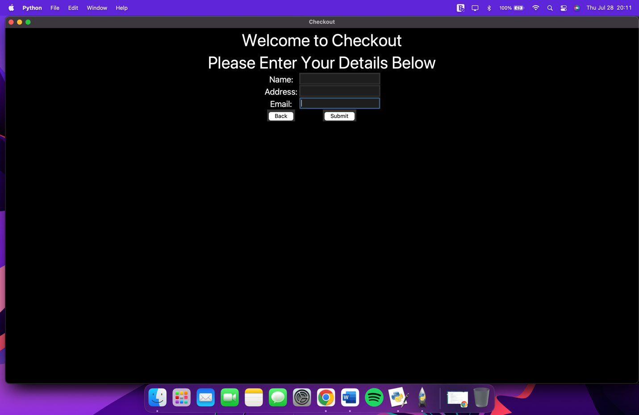

In the checkout window you can enter your personal details. You can also click the “Back” button to go back to shopping.

Name: Please enter your first and last name

Address: Please enter an address

Email: Please enter a valid email address

After you have submitted your details correctly you can click submit to submit your information to the application. This will send you to the final window.

Thank You Window: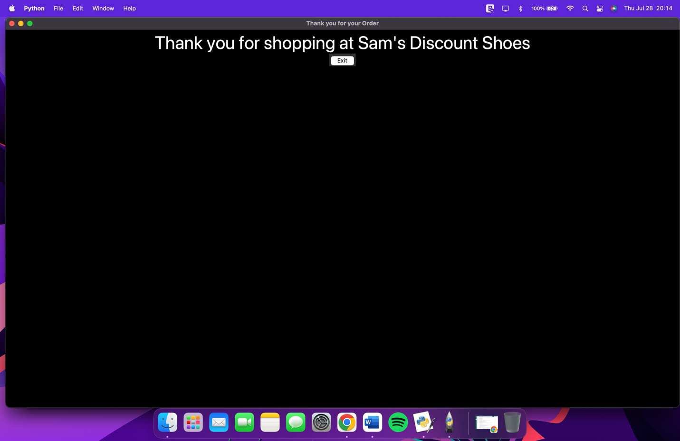

This window will display a thank you message for shopping at the store. You can then click “Exit” to exit the application.

I hope you enjoy my application and find it easy to use!